Case Study Report



**Tech Saksham**

Data Analytics with Power BI

**“360-degree Business Analysis of Online Delivery Apps using Power BI”**

**“A.P.C.Mahalaxmi College for Women”**

|  |  |
| --- | --- |
| **NM ID** | **NAME** |
| F82FCAB84DBDBF6B951410D6AF94F4A6 | M.YUVA RANI |

|  |  |
| --- | --- |
|  |  |
|  | Trainer Name:Mrs.Arockiya Jeyanthi |
|  | Master Name:Mrs.UmaMaheswari |

**ABSTRACT**

Online delivery apps have revolutionized the way consumer access goods and services,offering unparalleled convenience and accessibility.This case study employs Power BI,a powerful business intelligence tool,to conduct a comprehensive analysis of the online delivery app industry.By user demographics,delivery patterns,market trends and customer feedback,this analysis provides insights into key business aspects such as user behavior,market penetration,operational efficiency and revenue generation.

**INDEX**

|  |  |  |
| --- | --- | --- |
| **Sr. No.** | **Table of Contents** | **Page No.** |
| 1 | Chapter 1: Introduction | 4 |
| 2 | Chapter 2: Services and Tools Required | 7 |
| 3 | Chapter 3: Project Architecture | 9 |
| 4 | Chapter 4: Modeling and Result | 11 |
| 5 | Conclusion | 15 |
| 6 | Future Scope | 16 |
| 7 | References | 17 |
| 8 | Links | 18 |

**CHAPTER 1**

**INTRODUCTION**

* 1. **Problem Statement**

Food delivery companies might sometimes fail,owing to poor customer experience.Apps for food delivery offer a wide range of restaurants and cafes.It might be difficult to integrate information on all of them into a logical and accessible style.A mobile application’s displays should all have the same look and feel,with a consistent UI/UX.

**1.2Proposed Solution**

Hire a reputable food ordering app development company to create an app that will appeal to consumers and provide a consistent look and experience across all kinds of devices with varying screens sizes.

* 1. **Feature**
* **User-Friendly Registration:**Signing up for the app should be a quick and painless process,often allowing login through social media accounts.
* **Intuitive Interface:**The app should easy to navigate ,with clear menus and search functions to find the desired items or restaurants.
* **Real-Time Order Tracking:**This users lets see the progress of their order,from confirmation to preparation and delivery,often using GPS.
* **Secure Payment Options:**Secure in-app payment options are essential,with various methods like credit cards,debit cards,and digital wallets.
* **Ratings and Reviews:**Reading reviews from other customers help users make informed decisions about what to order.
* **Push Notifications:**Apps can send notifications about order status updates,promotionsand exclusive deals.
* **In-App Support:**Features like live chat or a FAQ section allow users to get help with any issues within the app.
  1. **Advantages**
* **Convenience**: Users can order from the comfort of their home or workplaces,saving time and effort compared to traditional shopping.
* **Wide Variety**: These apps provide access to a vast range of products and services,from groceries and meals to electronics and household items.
* **Fast Delivery**: Many online delivery apps offer quick delivery options,ensuring that orders reach customers promptly,sometimes within hours.
* **Customization:**Many apps allow users to customize their orders,such as selecting ingredients or specifying delivery instructions,catering to individual preferences.
* **Accessibility:**Online delivery apps are accessible 24/7,allowing users to place orders at any time that suits them.
* **Transparency:**Users can track their orders in real-time,knowing exactly when to expect delivery,enhancing transparency and trust.
* **Deals and Discounts:**Apps often offer exclusive deals,discounts,and loyalty rewards,making online shopping more cost effective compared to traditional methods.
* **Contactless Transactions:**Especially relevant during the COVID-19 pandamic,contactless payments and delivery,reducing the risk of exposure to viruses.

**1.4 Scope**

The scope of food delivery app development is expected to grow significantly in the next decade as more people rely on online food ordering.Increased smartphone usage and convenience will drive the demand for food delivery apps.

The food delivery app market is expected to experience significant growth in the next five years,and a good UI/UX design can play a crucial role in attracting and retaining customers.Food delivery apps that invest in designing user-centric experiences are poised to see the most success in the future.

**CHAPTER 2**

**SERVICES AND TOOLS REQUIRED**

* 1. **Services Used**
* **Data Integration Services:**Services for data integration are crucial for collecting and consolidating data from various sources such as transactional databases,customer feedback platforms,delivery tracking systems and market research databases.Tools like Microsoft Power Automate,Azure data factory,or third party services like Zapier can be used for seamless data integration.
* **Data Warehousing:**Storing and organizing data efficiently is essential for performing analytics effectively.Data Warehousing services such as Azure Synapse Analytics or Amazon Redshift can be used to store large volumes of structured and unstructured data for analysis.
* **Cloud Storage:**Cloud storage solutions like Azure Blob Storage or Amazon S3 can be used to store raw data,intermediate data,and processed datasets securely,making it accessible for analysis by Power BI and other tools.
* **Machine Learning Services:**Integrating machine learning models into analysis pipeline can provide predictive analytics capabilities for tasks such as demand forecasting,customer segmentation, and route optimization.Azure Machine Learning or Amazon Sagemaker are examples of machine learning services that can be integrated with Power BI.

**2.2 Tools and Software used**

**Tools**:

* **PowerBI**: The main tool for this project is PowerBI, which will be used to create interactive dashboards for real-time data visualization.
* **Power Query**: This is a data connection technology that enables you to discover, connect, combine, and refine data across a wide variety of sources.

**Software Requirements**:

* **PowerBI Desktop**: This is a Windows application that you can use to create reports and publish them to PowerBI.
* **PowerBI Service**: This is an online SaaS (Software as a Service) service that you use to publish reports, create new dashboards, and share insights.
* **PowerBI Mobile**: This is a mobile application that you can use to access your reports and dashboards on the go.

**CHAPTER 3**

**PROJECT ARCHITECTURE**

**3.1 Architecture 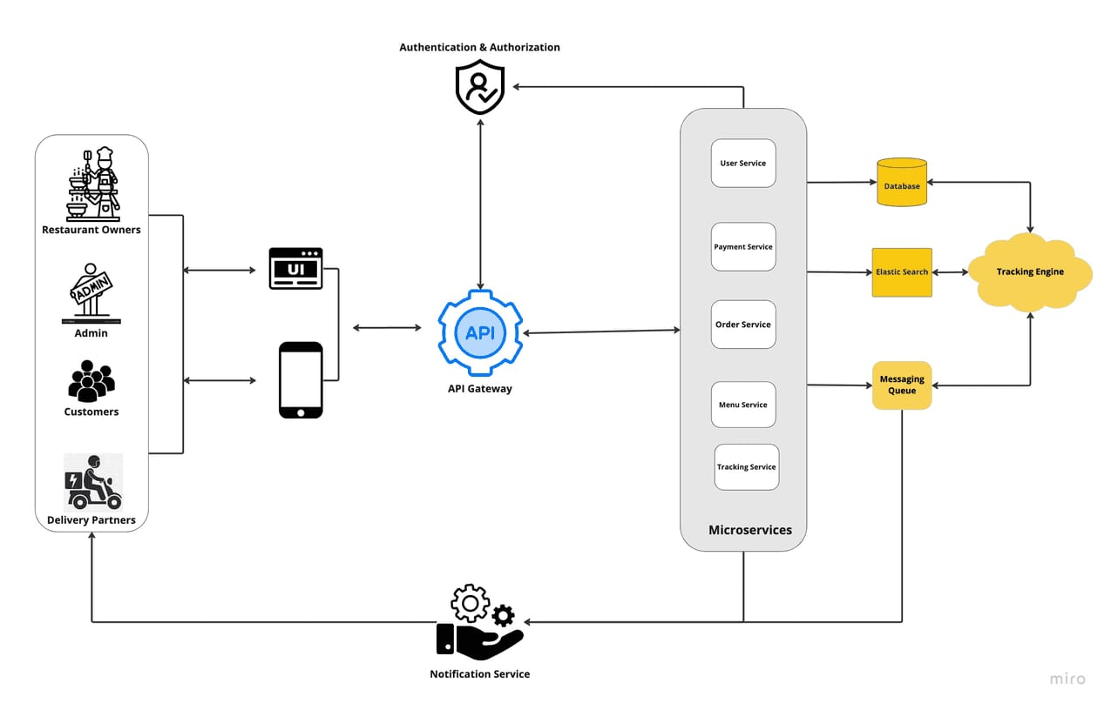Components of the system:**

To Start with,an online delivery system typically consists of several components,including:

**1.Frond-end web or mobile application:**This is the interface customers use to generate menus,browse menus,place orders,and track delivery status.

**2.Backend server or Services:**This component handles requests from the front end,communicates with the database,coordinates with delivery partners.

**3.Database:**This stores information about menus,orers,customers,and delivery partners.

**4.API Gateway:**This is responsible for request routing ,composition,and protocol translation,among other things,between an application and a set of microservices.

**5.Messaging Queue:** An asynchronous communication between systems that allows multiple systems to send and receive messages reliably and efficiently without needing to be constantly connected.

**6.Notification Service:**To send notifications to users,typically through email or push notifications.

**7.Tracking Engine:**This will constantly watch for changes in the DB,update the elastic search index,and notify the messaging queue

The front-end web or mobile application will communicate with the backend servers over REST API;the server will process the request and query the database based on the request;it will perform a task,emit events,respond to the request and many more

**CHAPTER 4**

**MODELING AND RESULT**

**Manage Relationship:**

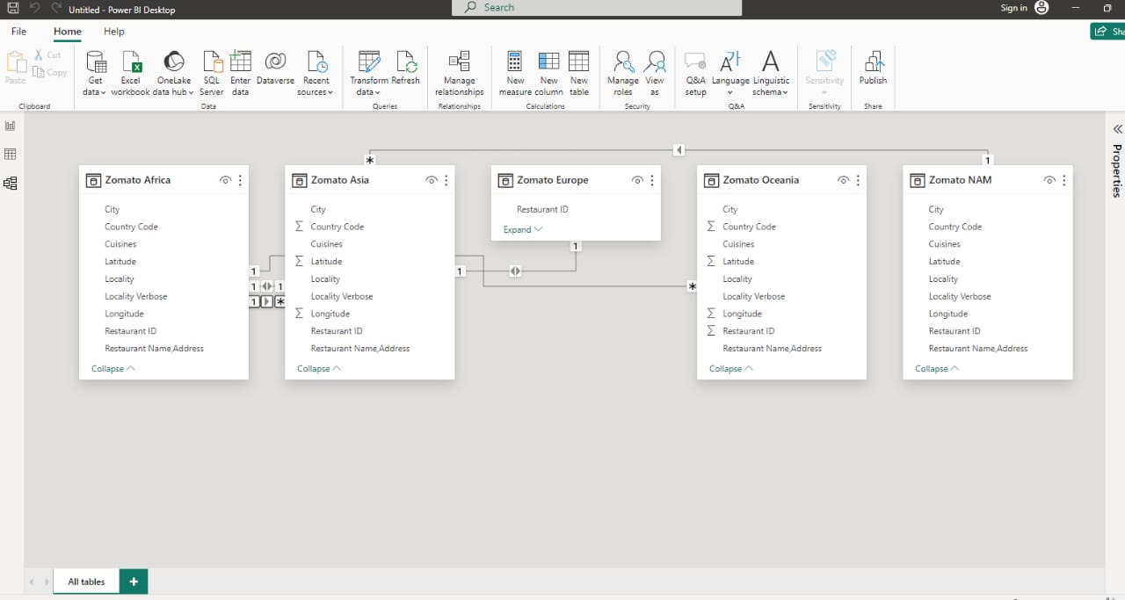

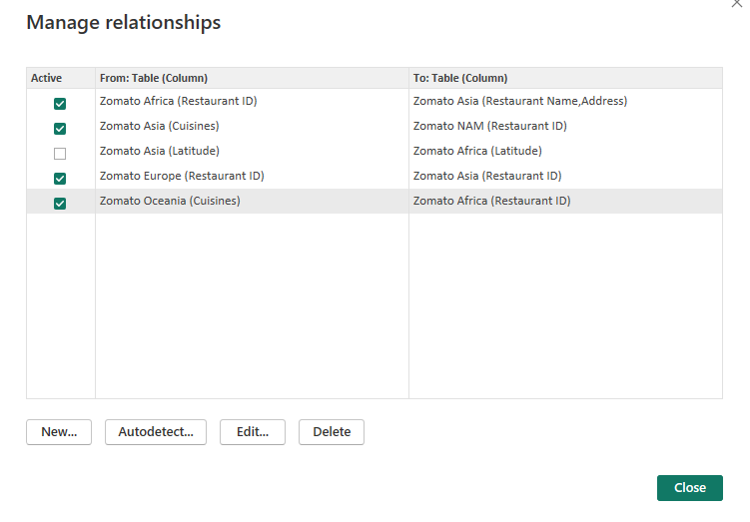

**Edit Relationship:**

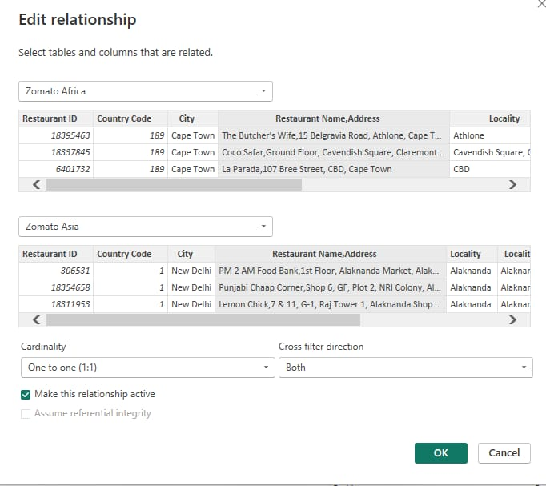

.

.

.

**Dashboard**

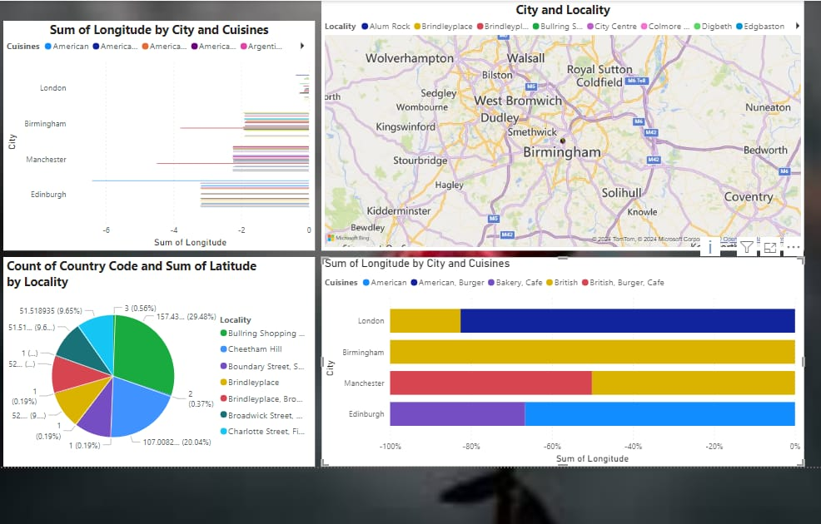

**CONCLUSION**

Online delivery apps have become a major convenience factor in our lives.They offer a wide variety of benefits,including:

* **Saving time and effort:**No more need to spend time shopping in person,especially for groceries.
* **Access to a wider selection of items:**Order from a variety of restaurants and stores that you might not be able to get to yourself.
* **More Convenient way to get essentials:**Get groceries,medicine,and other household items delivered straight to your door.

Overall,Online delivery apps offer a valuable service that can make our lives easier.However,it’s important to weigh the benefits and drawbacks before you decide whether to use tham.

**FUTURE SCOPE**

The industry is constantly evolving with new features and services emerging all the time.Here are some potential areas of growth.

* **Ultra-Fast Deliveries:**Companies are exploring ways to deliver items in under an hour using drones,autonomous vehicles,or innovative delivery methods.
* **Subscription Services:**Delivery apps with subscription models could offer exclusive deals,faster deliveries,or other perks to loyal customers.
* **Integration with Smart Homes:**Imagine a future where your fridge automatically reorders groceries when supplies run low,or your medicine cabinet gets refilled through a delivery app.

Overall,online delivery apps are transforming the way we shop and receive goods.Their scope continue to broaden,offering ever-greater convenience and efficiency for both consumers and businesses.

**REFERENCES**

<https://cuzegbu.medium.com/ux-case-study-food-delivery-app-design-2a001c78db96>

<https://pratapsharma.com.np/architecture-of-food-delivery-app/>

**LINK**